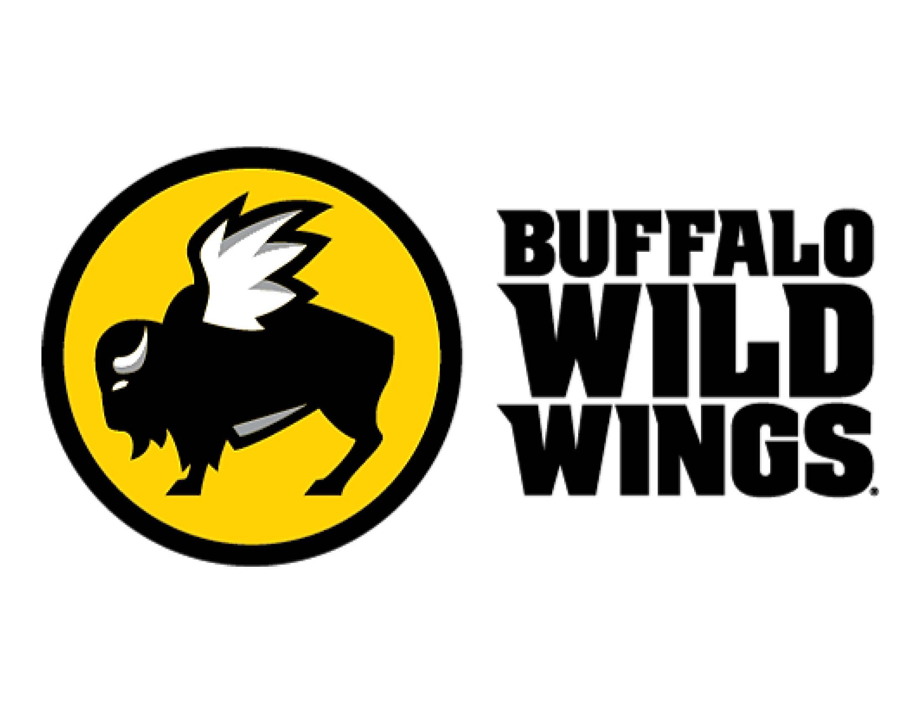

For Immediate Release Contact: Angela Krile
C: 740-974-3948

Buffalo Wild Wings® Canal Winchester Donates more than 80 Sauce Bottles to Troops Overseas

Canal Winchester, OH – The Buffalo Wild Wings® located in Canal Winchester recently donated more than 80 Buffalo Wild Wings sauce bottles to United States troops overseas.

During the month of December, patrons were able to purchase a bottle of famous Buffalo Wild Wings sauce and donate it directly to serving members of the U.S. Military. The bottles were collected and donated to the Blue Star Mothers of America, Inc. Ohio Chapter 10 and will soon be shipped overseas to the men and women of our Armed Forces to help spice up their New Year.

Franchise owner Larry Tipton elaborated on the event, “I’ve heard from several veterans that when they were eating MREs, Buffalo Wild Wings sauce was one of their favorite things to put on the food to make it taste more like home. We’re honored that we are able to help spice up the New Year for our troops by having offered this program at our location.”

For more information on Buffalo Wild Wings, visit http://lancasterwings.com/ .

The Canal Buffalo Wild Wings® is located on Prentiss School Street and is owned and operated by Lancaster entrepreneur, Larry Tipton. Larry Tipton currently owns and operates Buffalo Wild Wings franchise locations in Lancaster, Athens, Heath, Canal Winchester, Reynoldsburg, and Mount Vernon, as well as two locations in Arizona - Flagstaff and Prescott Valley.

###

